
CARBON REDUCTION PLAN GUIDANCE

Notes for Completion
Where an In-Scope Organisation has determined that the measure applies to the procurement, suppliers wishing to bid for that contract are required at the selection stage to submit a Carbon Reduction Plan which details their organisational carbon footprint and confirms their commitment to achieving Net Zero by 2050.
Carbon Reduction Plans are to be completed by the bidding supplier and must meet the reporting requirements set out in supporting guidance and include the supplier’s current carbon footprint and its commitment to reducing emissions to achieve Net Zero emissions by 2050.
The CRP should be specific to the bidding entity, or, provided certain criteria are met, may cover the bidding entity and its parent organisation. In order to ensure the CRP remains relevant, a Carbon Reduction Plan covering the bidding entity and its parent organisation is only permissible where the detailed requirements of the CRP are met in full, as set out in the Technical Standard and Guidance, and all of the following criteria are met:
- The bidding entity is wholly owned by the parent.
- The commitment to achieving net zero by 2050 for UK operations is set out in the CRP for the parent and is supported and adopted by the bidding entity, demonstrated by the inclusion in the CRP of a statement that this will apply to the bidding entity.
- The environmental measures set out are stated to be able to be applied by the bidding entity when performing the relevant contract; and
- The CRP is published on the bidding entity’s website.

Bidding entities must take steps to ensure they have their own CRP as soon as reasonably practicable and should note that the ability to rely on a parent organisation’s Carbon Reduction Plan may only be a temporary measure under this selection criterion.
The Carbon Reduction Plan should be updated regularly (at least annually) and published and clearly signposted on the supplier’s UK website. It should be approved by a director (or equivalent senior leadership) within the supplier’s organisation to demonstrate a clear commitment to emissions reduction at the highest level. Suppliers may wish to adopt the key objectives of the Carbon Reduction Plan within their strategic plans.

HTG-UK, Danwood House, Harrison Place, Whisby Road, LINCOLN, LN6 3AH

Supplier name: HTG-UK
Publication date: September 2022

Commitment to achieving Net Zero

HTG-UK are committed to achieving Net Zero emissions by 2040.

Baseline Emissions Footprint
Baseline emissions are a record of the greenhouse gases that have been produced in the past and were produced prior to the introduction of any strategies to reduce emissions. Baseline emissions are the reference point against which emissions reduction can be measured.
Baseline Year: 1st January to 31st December 2018
Additional Details relating to the Baseline Emissions calculations.

HTG-UK’s baseline is built upon our ESOS Phase 2 reporting data which was formally notified to the Environment Agency. This is calendar year 2018 and captures the ESOS qualification date of 31st December 2018. Our ESOS Phase 3 is currently in progress with our independent consultants who have completed site audits and fleet profiling and inspections.
As the ESOS phase 3-year mirrors the calendar year reference period ESOS Phase 2, we are awaiting data from now until 31st December 2022 before we can report. HTG-UK have not previously been captured by SECR, but we are working on gathering data for the relevant period.
Baseline year emissions: 2018
EMISSIONS | TOTAL (tCO₂e)
Scope 1 | 3,183
Scope 2 | 138
Scope 3  (Included Sources) | 410  Grey Fleet, (water and waste tbc). It is our intention during 2023, to work with our suppliers to assist them with their understanding of their journey towards net zero carbon and to assist the to compile and assess their scope 1 and 2 emissions which will form our scope 3 emissions.
Total Emissions | 3,730

Current Emissions Reporting

Reporting Year: 1st January 2022 to 31st December 2022
EMISSIONS | TOTAL (tCO₂e)
Scope 1 | Data from July to December 2022 awaited. Narrative:  Following our baseline, we have moved all bar one of our company cars to battery electric vehicles. The one that remains, is a Plug-in Hybrid Electric Vehicle (PHEV) and we plan to move this to a Battery Electric Vehicle (BEV) at the next contract change. We have also installed EV charge points at several our sites. This to allow for on-site charging of these and future vehicles.
Scope 2 | Data from July to December 2022 awaited. Narrative:  We have begun to transition our premises lighting to LED across our sites and now operate better control over our air-to-air heat pumps such that we have locked comfort zones and are instigating an energy policy for staff.
Scope 3  (Included Sources) | Data from July to December 2022 awaited. Narrative:  Grey Fleet, (water and waste tbc).  We are in discussions with our consultants about moving some of our grey fleet to company cars and, where possible making these BEVs. This will not only reduce our emissions but will also allow us to take better control over this aspect of our fleet.
Total Emissions | Data from July to December 2022 is awaited and this will form our Energy Efficiency Directive (EED) ESOS Phase 3 submission and our next assessment of our emissions which we expect to collect annually from then on. We expect to have our ESOS assessment completed, agreed and the Environment Agency notified of our compliance during Q2/3 2023 and begin acting on its recommendations from then. Our ESOS report will include not only our kWh and litre usage, but will be converted to absolute CO2e figures as well as intensity metrics for square metreage where these are known and our miles travelled. We will also have CO2e figures against each of our energy and fuel sabing recommendations to allow us to better plan our trajectory toewards net zero carbon (CO2e).

Emissions reduction targets
The above represents the organisation’s baseline. Due to internal changes in the organisation, not least the transition from TASL to HTG-UK and the massive effects that Covid-19 had on our organisation as a healthcare provider from March 2020, we have not yet been able to accurately document our emissions post our 2018 baseline.

In order to continue our progress to achieving Net Zero, we have adopted the following carbon reduction targets.

Targets

We have expectations to follow the NHS targets, specifically:
- For the emissions we control directly (the NHS Carbon Footprint), we will reach net zero by 2040, with an ambition to reach an 80% reduction by 2028 to 2032.
- For the emissions we can influence (our NHS Carbon Footprint Plus), we will reach net zero by 2045, with an ambition to reach an 80% reduction by 2036 to 2039.

Our CO2e footprint in terms of scope is tabled below:

Scopes | %Age | Tn CO2e
Scope 1 | 85.3 | 3,183
Scope 2 | 3.7 | 138
Scope 3 | 11.0 | 410
Total | 100.0 | 3,730

And graphed as below:
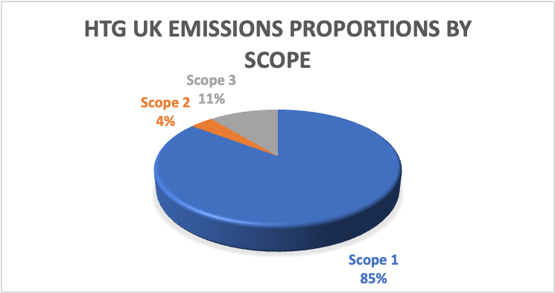

We recognise that as an organisation, our transport is our largest emitter. This is apparent in the following table:
Scopes | %Age | Tn CO2e
Scope 1 Space Heat & F Gas | 0.2 | 9
Scope 1 Transport | 85.1 | 3,174
Scope 2 Electricity | 3.7 | 138
Scope 3 Transport | 10.7 | 400
Scope 3 Water and Waste | 0.3 | 10
Total | 100.0 | 3,730

With graph exemplifying this:

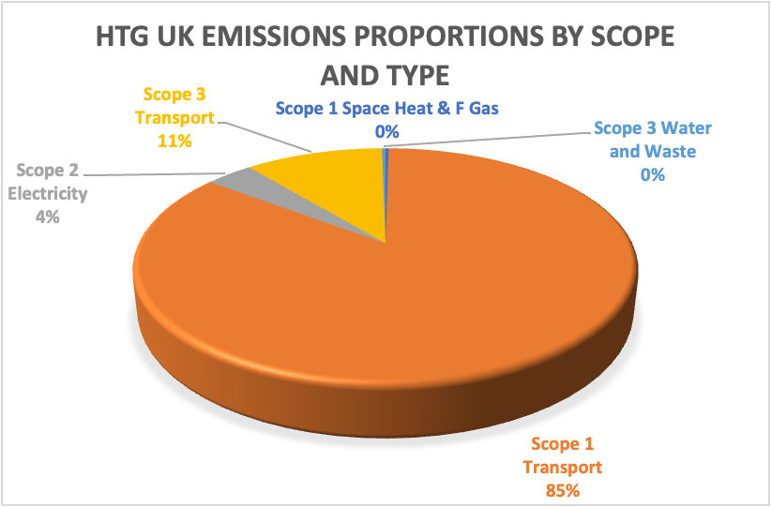

Carbon Reduction Projects

Completed and progressing Carbon Reduction Initiatives

The following environmental management measures and projects have been completed or implemented since our 2018 baseline. The carbon emission reduction achieved by these schemes is significant. These measures will be in effect when performing the contract. We fully intend to move our fleet towards zero carbon at the exhaust as technologies and practicability allows.

Given that our significant energy consumer is our fleet, our principal focus is to devote our energies to reducing our transport emissions through specific SMART actions directed at our fleet vehicles, using technologies, measures, controls, and driver behaviours.

After a 12-month trial period, we have recently appointed a new telematics provider and will have accurate telematics across our fleet from late October 2022. This will allow us to monitor and target poor driver behaviour and help establish where to focus our early changeovers to BEV ambulances and wheelchair accessible vehicles.

We have already moved our directors and managers cars to BEVs (and one PHEV).
Having rolled out LED lighting at certain of our sites, we continue to deliver this at sites where this is practicable and viable. There were only three of our sites at Louth, Leicester and Wath, that heat with gas. The remaining sites are electrically heated, two with efficient air-to-air heat pumps.

Work in Progress

We recognise that our electrical infrastructure needs work to improve capacity and allow additional EV charge points to be introduced at our centres. Not only will this help make us energy independent in the event of fuel shortages and strikes etc but will allow our drivers the peace of mind of knowing that they don’t necessarily have to rely on public charging infrastructure.
We are looking at several of our sites with a view to electrifying heat and removing gas heating. Naturally, some of these sites rely on landlord agreements.

We are considering PAS2060 although at this stage our focus is on implementing tangible and actual measures and not relying on sequestration and offsetting. Our aims, as far as reasonably practicable are to be net zero as opposed to carbon neutral. We are placing emphasis on ESOS as opposed to ISO 50001 as we understand that at this stage, the former will provide us with more calculated and actual actionable opportunities to implement.
This report has been conducted using the guidance of the Greenhouse Gas Protocol. HTG-UK still operates as Thames Ambulance Service (TASL) in Leicestershire and Lincolnshire. The company is accredited to ISO 14001 (2015) No: 324322021 and IS 9001 (2015) No: 324262021. Is this still the case?

We project that carbon emissions will decrease significantly over the next five years and with the measures in place. Assuming same size operational fleet as of 2018, we expect to see a 10%-15% reduction in emissions by 2026. We will have a much clearer appreciation of this post our ESOS reporting in early 2023. It is important to us that all our targets and emissions reductions calculations are SMART and can be verified independently.

Direction of trajectory against these targets can be seen in the graph below:

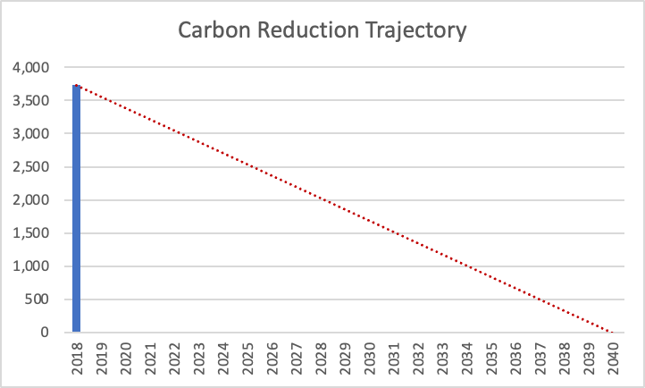

Estimates and exceptions

Our electricity and gas data are built around our ESOS Phase 2 data which was independently compiled and notified to the Environment Agency in accordance with the directive (2012/EU/27) and which contains some estimates due to non-half hourly billing at most sites and reliance on readings and estimates.

Our water use is based on an extrapolation of water billing for a similar period for three sites, calculation for water use per staff member at these sites is then calculated for staff numbers at each site during be baseline year.

Our waste and recycling data is based on Eurobin lifts and litre data in 200/21 which did not change since 2018 for five sites and extrapolated for remaining sites based on staff numbers during our baseline year. A figure for litres to kg of material has been provided using the UK Government’s waste classification scheme for commercial paper and card. Our material is not source segregated but goes for closed loop recycling.

In the future we hope to implement further measures such as:

A move of our wheelchair accessible vehicles and ambulances to battery electric vehicles. The increased electrical capacity at our sites and roll out of more electric vehicle charging infrastructure.
The installation of renewable energy including solar PV arrays.
Continued operations on energy efficiency measures, controls and behaviours within our buildings and across our fleet through the more consistent use of our new and more intelligent telematics system that will be operation from November 2022.

Having delivered several of the recommendations for our ESOS Phase 2 report, we are awaiting the findings of the ESOS Phase 3 report, due in spring 2023 to begin further work on our estate and fleet.

Declaration and Sign Off
This Carbon Reduction Plan has been completed in accordance with PPN 06/21 and associated guidance and reporting standard for Carbon Reduction Plans.
Emissions have been reported and recorded in accordance with the published reporting standard for Carbon Reduction Plans and the GHG Reporting Protocol corporate standard and use the appropriate Government emission conversion factors for greenhouse gas company reporting.
Scope 1 and Scope 2 emissions have been reported in accordance with SECR requirements, and our subset of Scope 3 emissions have been reported in accordance with the published reporting standard for Carbon Reduction Plans and the Corporate Value Chain (Scope 3) Standard.
This Carbon Reduction Plan has been independently produced from HTG-UK data by our consultants CLS Energy (Consultancy) Ltd and reviewed and signed off by the board of directors.

Signed on behalf of the Supplier:
Signed
Name
Position Director
Company HTG UK
https://www.htg-uk.com
Date: 16th September 2022

Signed on behalf of independent report producer:
Signed 
Name Alan Asbury
Position Director
Company CLS Energy (Consultancy) Ltd
https://clsenergy.com
Date: 16th September 2022

Bidding supplier or ‘bidding entity’ means the organisation with whom the contracting authority will enter into a contract if it is successful.
Technical Standard can be found at: https://assets.publishing.service.gov.uk/government/uploads/system/uploads/attachment_data/file/991625/PPN_0621_Technical_standard_for_the_Completion_of_Carbon_Reduction_Plans__2_.pdf
Guidance can be found at: https://assets.publishing.service.gov.uk/government/uploads/system/uploads/attachment_data/file/991623/Guidance_on_adopting_and_applying_PPN_06_21___Selection_Criteria___3_.pdf
https://ghgprotocol.org/corporate-standard
https://www.gov.uk/government/collections/government-conversion-factors-for-company-reporting
https://ghgprotocol.org/standards/scope-3-standard

